Dr. Cheryl L Brown, Director  Jacksonville City Council  904.630.1452  CLBrown@coj.net | 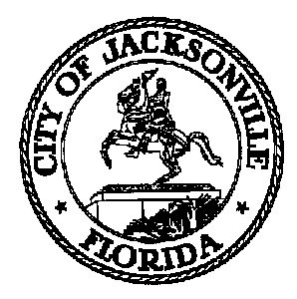 | 117 West Duval Street, Suite 425  Jacksonville, Florida 32202
TASK FORCE ON SAFETY AND CRIME REDUCTION

Meeting Notice

February 21, 2019
5:00 p.m.

TO: Task Force on Safety and Crime Reduction Subcommittee Members
Tom Geismar | Timothy Sloan
Phyllis Hall | Shamika Wright
Alicia Sitren | Mia Allen

FROM: Ellen Glasser, Chair

SUBJECT: 20190301 Meeting Notice Task Force on Safety and Crime Reduction Subcommittee on
Family Engagement

Notice is hereby given that the Task Force on Safety and Crime Reduction
Subcommittee on Family Engagement will meet Friday, March 1, 2019 from 9:00 AM – 10:00 AM. The meeting will be held in Conference Room A, 117 W. Duval St., 4st Floor, City Hall - St. James Building. For additional information, please contact Crystal Shemwell at cshemwell@coj.net or (904) 630-1404.

When attending Task Force meetings, members are to park in the parking garage located on the corner of Main and Duval Street (Library Garage) to receive free parking. Please see the Legislative Assistant for parking validation.

Pursuant to the American with Disabilities Act, accommodations for persons with disabilities are available upon request. Please allow 1-2 business days notification to process; last minute requests will be accepted, but may not be possible to fulfill. Please contact Disabled Services Division at: V(904) 630-4940, TTY-(904) 630-4933, or email your request to KLMcDan@coj.net.

CLB/cs
cc: Cheryl Brown, Council Director
Carol Owens, Chief of Legislative Services
Jeff Clements, Chief of Research
File
cityc@coj.net

